**Wye Knot Women's Wilderness Adventure: Snowdonia Edition!**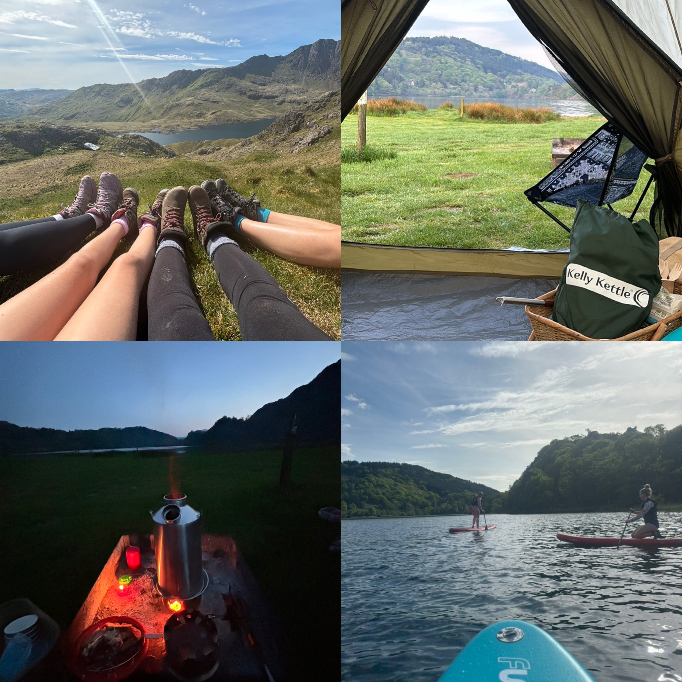

Calling all adventurous ladies!

This year, Wye Knot Community is taking you on an epic weekend in the heart of Snowdonia National Park!

Join us for breathtaking hikes, exhilarating paddleboarding, cosy campfire cooking, and essential bushcraft skills – all led by our amazing team of female guides.

**Here's what awaits you:**

* Conquer Snowdon: Hike to the summit of Wales's highest peak, tackling challenging but rewarding trails with stunning views.
* Paddle-board Paradise: Master the art of paddleboarding on the glassy waters of Llyn Gwynant, a beautiful lake nestled beneath Snowdon. Our qualified coach will guide you every step of the way.
* Campfire Feasts: Learn to cook delicious and nutritious meals over an open fire, fostering teamwork and creating unforgettable memories.
* Bushcraft Basics: Gain valuable wilderness skills like shelter building and firecraft, empowering you to explore nature with confidence.
* Reconnect with Nature: Immerse yourself in the serene beauty of Snowdonia, forging connections with fellow adventurers and rediscovering inner peace.

**This trip is perfect for:**

* Anyone wanting to try new outdoor activities
* Nature lovers seeking an unforgettable adventure
* Women looking to meet like-minded friends and empower themselves

No prior paddleboarding experience is required! Our expert female coach will ensure you feel safe and comfortable on the water.

Conquer Snowdon (Moderate Fitness Level Required): Hike to the summit of Wales's highest peak, tackling challenging but rewarding trails with stunning views. We recommend a moderate level of fitness for this hike, as it involves ascending and descending on uneven ground.

* Limited Spots Available: This exclusive experience is capped at 10 participants for a personalised and intimate journey.
* Cost: £350. This covers:
  + All meals and drinks throughout the weekend, including a fun pizza night!
  + Expert instructors and equipment for paddle Boarding
  + highly qualified female guides accompanying you for the entire adventure

**Itinerary**:

* Dates 2024: May the 9th-11th
* October the 3rd-5th
* Start Time: Friday, 4 pm onward meeting at Llyn Gwynant Campsite
* End Time: Sunday, 10 am

**Unforgettable Activities:**

* Snowdon Summit: Challenge yourself with a guided hike to the top of Snowdon, taking in breathtaking panoramic views.
* Paddle-board Bliss: Glide across the tranquil waters of Llyn Gwynant under the expert guidance of our female coach.
* Culinary Creations by Firelight: Learn to cook delicious meals under the stars, fostering teamwork and creating lasting memories.
* Bushcraft for Beginners: Gain valuable wilderness skills like whittling and fire-craft, empowering you to explore with confidence.

More Than Just an Adventure:

* A Night of Pizza Perfection: Treat yourselves to a fun pizza delivery night after conquering Snowdon!
* Relaxing Pilates: Unwind and revitalise your body with a guided yoga session led by one of our female instructors.

**Basecamp Bliss at Llyn Gwynant Campsite:**

Nestled in the heart of Snowdonia, Llyn Gwynant Campsite offers breathtaking views and a serene atmosphere. Choose between wild camping with your newfound skills, and a cosy bell tent.

**We are a Dream Team of Women**:

This trip is run entirely by a passionate team of female guides and instructors. Their expertise and enthusiasm will ensure you have a safe, empowering, and unforgettable adventure.

**Dietary Requirements:**

All dietary requirements will be catered for. Just let us know your needs upon booking.

**Contact**:

Ready to join the adventure? Get in touch with Rose Sales at 07891538974 or visit our website at [www.wyeknotcommunity.com](https://www.wyeknotcommunity.com/). Don't miss out on this incredible opportunity to explore the beauty of Snowdonia with a supportive group of women!